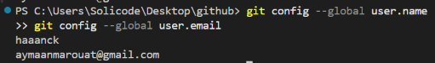
Git or GitHub?
Action | Git or GitHub?
Save a commit on your computer | Git
View a colleague’s repository on the Internet | GitHub
Create a project’s history without a connection | Git
Send your code to share it online | GitHub
